EddystoneSDK part description
In EddystoneSDK, you can view its source code. Where the EddystoneClass class is the processing of Bluetooth radio data, the data package into Eddystone objects,Eddystone objects can be stored in three kinds of broadcast data, but in different Bluetooth broadcast mode, Eddystone objects inside the different member variables have different values; For example, iBeacon mode, only eddystone. deviceUuid, eddystone. major, eddystone. minor and other members of the variable has a numerical value; In UID mode, only eddystone. nameSpaceID, eddystone. instanceID and other members of the variable has a numerical value; In URL mode, only the eddystone.url has a numeric value; Above each member variable only has the corresponding pattern to have the value, please do not use the other mode member variable, For example, in the iBeacon mode, please do not use the eddystone.nameSpaceID or eddystone.url. The eddystone.deviceName, eddystone.deviceAddress, eddystone. Rssi and eddystone.type are three kinds of patterns common to all member variables, Among them, eddystone.type is used to indicate the type of the unused, 1 represents the iBeacon mode, 2 represents the UID mode, and 3 represents the URL mode.

EddystoneSDKexample part description:
1, EddystoneSDK initialization
EddystoneSDK.initialize (); must be in the onCreate () method of the Application or Activity for initial processing.
2,Get Bluetooth object eddystone
After scanning to the Bluetooth device, in the BluetoothAdapter.LeScanCallback (Android 5 System) or ScanCallback (Android 5 system or above) in the callback method to get the Eddystone object , As shown below:
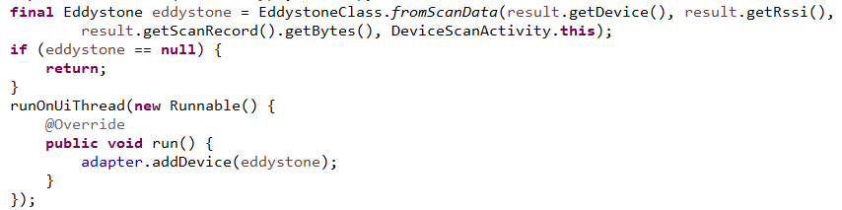
When eddystone.type==1, this is a kind of iBeacon, eddystone. deviceUuid, eddystone. major, eddystone. minor and other members of the variable has a numerical value， eddystone. nameSpaceID, eddystone. instanceID, eddystone.url and other member variables have no value，Please do not use these other mode private member variables.
When eddystone.type==2, this is a kind of UID, only eddystone. nameSpaceID, eddystone. instanceID and other members of the variable value, Eddystone. deviceUuid, eddystone. major, eddystone. minor, eddystone.url and other member variables have no value, please do not use.
When eddystone.type==3, this is a kind of URL, only eddystone.url member variables have values, eddystone. deviceUuid, eddystone.major, eddystone.minor, eddystone. nameSpaceID, eddystone. instanceID and other member variables have no value, please do not use.
3, enter the modified activity
When we enter the modified activity, you can be judged according to eddystone.type, and Bluetooth connectivity, the name of the device must contain “_n”, not to modify their own, As shown below:
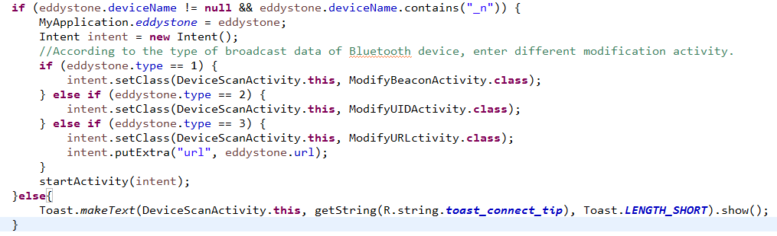
In the onCreate(Bundle savedInstanceState)of the ModifyBeaconActivity、ModifyUIDActivity、ModifyURLctivity Class, We have to set the device callback, use eddystone.setDeviceListener(this); Then the device is connected to use eddystone.connect (),As shown below:
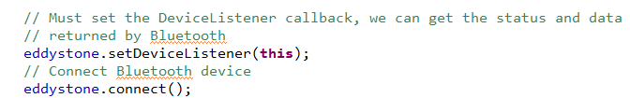
Before modifying the data, we must determine the boundaries of the data to be modified, and to verify the password,As shown below:
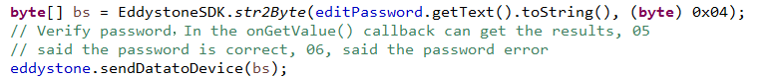

（1）The ModifyBeaconActivity class is used to modify the data in the iBeacon mode,
After the success of the password to verify the password can be modified with various parameters, which modify the UUID as follows:
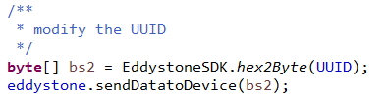
Modify major, minor, period, txpower and other parameters are as follows:
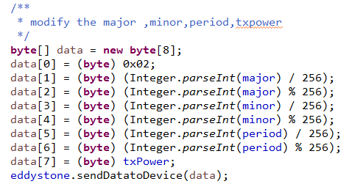
Modify the device name as follows, other modes of the device name changes the same way:
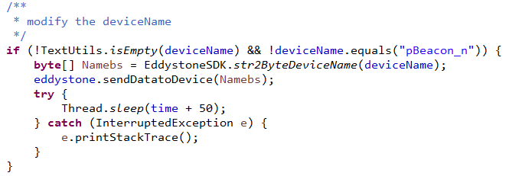
After all the parameters are modified, you must send the command to close the Bluetooth device, in order to modify the success:
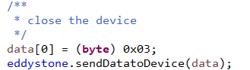
(2) The ModifyUIDActivityclass is used to modify the data in the UID mode;
Which modify the nameSpaceId and instanceId, as follows:
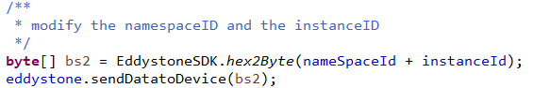
Modify txpower, period and other parameters:
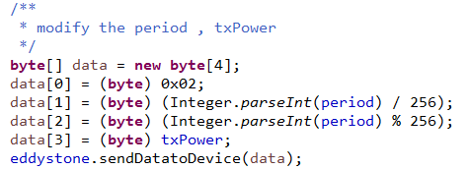
(3) The ModifyUIDActivityclass is used to modify the data in the UID mode; Which modify the url; in the modification of URL, it is necessary to carry out strict boundary determination and accurate data conversion ,as follows:
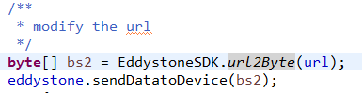
Modify txpower, period and other parameters:
(4) In the ModifyPassActivity class, used to modify the password:

